Группы 1т-90, 1т-91, 1т-92к, 1т-93к, 1то-04к, 1тэ-05, 1тэ-06к
Иностранный язык
Преподаватель Жмаева Татьяна Владиславовна
Задание с 20.03 по 26.03
№ 1. Соединить названия мест и то, чем они прославились (цифра – буква).
№2. Вставить пропущенные слова в предложения (цифра – буква).
№3 Написать конспект правила «Определенный Артикль с географическими названиями в английском языке» (можно на русском языке, грамматический материал есть в номере 3 либо в интернете).
№4. Пользуясь правилом из №3, поставить артикль the там, где нужно. Записать окончательный вариант (либо с артиклем, либо без артикля).
Задание с 27.03 по 02.04
№5. перевести текст устно. Прочитать перевод.
№6. Выписать из текста факты про каждую часть Англии (фразы на английском)
№7 Ответить на вопросы по тексту. Можно выделить их цветом в тексте / скопировать и поставить ответ рядом с подходящим вопросом / выписать в тетрадь. Любой вариант приемлем.
№8 Исходя из информации в тексте, догадаться, какие места обозначены цифрами на карте Англии (цифра – слово).
Сдать лично либо в электронном варианте в ЛС https://vk.com/zhm_tatiana (можно фото тетради)
1. Match the words in the two columns to say what these places are famous for.
Ex. London is famous for its museums.

- Kent
- Stonehenge
- Land ’s End
- Liverpool
- Cambridge
- Washington, D. C.
- New York
- Paris
- St. Petersburg
- Rome

- a group of huge stones of pre-historic times
- Winter Palace (the Hermitage)
- its university
- the fact that it’s the most western point in the country
- fruit growing and gardens
- a big port on the western coast
- the Eiffel Tower
- the White House
- the Coliseum
- the skyscrapers

2. Fill in the gaps with the missing words.

1. Great Britain is an ... that lies off the northwest of Europe.
2. ... separates the U.K. from the continent.
3. There are four countries in the United Kingdom: ... , ... , ... , ... .
4. The capital of G.B. is ... .
5. People often say that the English-man's home is his ... .
6. English people drink a lot of ... .
7. The most spectacular sport in Britain is ... .
A. London
B. island
C. castle
D. the English Channel
E. England
F. tea
G. Scotland
H. Wales
I. football
H. Northern Ireland.

3. Make a notes about the rule.
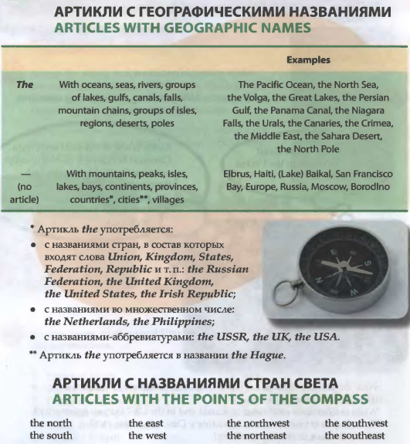
4. Which of the geographic names are used with the article? Write them down
1. Yenisei 2. Tokyo 3. South Pole 4. Laptev Sea 5. Egypt 6. Philippines 7. Indian Ocean 8. Sakhalin 9. People's Republic 10. Suez Canal 11. USSR 12. China 13. Middle East 14. Netherlands 15. Quebec 16. Kara-Kum 17. Ukraine 18. British Isles 19. Kilimanjaro 20. Far East 21. Hudson Bay
5. Read the text.
DISCOVER BRITAIN: ENGLAND
The United Kingdom is very small compared with many other countries in the world. However there are only nine other countries with more people, and London is the wor1d’s seventh biggest city. When you travel about the country you can see how the scenery changes right in front of your eyes. Highlands turn into lowlands, forests and hills turn into meadows and plains very quickly. Often what people first notice about Britain, especially if they arrive by plane, is the green of the fields, hedges and trees. Britain is an unusually beautiful country!
The Southeast is a highly populated region of England; there is a lot of industry near the Thames and there are a lot of roads and motorways. London, the capital of the UK, and such historical cities as Windsor, Dover and Brighton are situated here. When people travel to Britain by sea or air they usually arrive in the Southeast, for this is where the main passenger ports and airports are. Heathrow Airport, one of the world's busiest airports is about 33 km west of central London. However, there is still attractive countryside in the Southeast. The County of Kent situated here is known as the garden of England. The Southeast is famous for its resorts, Brighton is, probably, the best known of them.
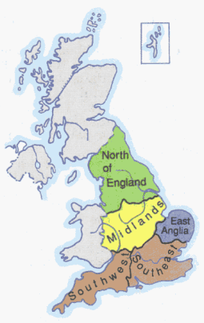
The Southwest is the region where the main activity is farming. Although there are some very big farms, most of them are small family farms where dairy products are produced. The Southwest used to be known for its pirates. The romantic past makes it a popular place for artists, writers and holidaymakers. The two principal cities of the region are Bristol and Bath. If you want to see the famous Stonehenge, one of the remarkable historic places in the UK, you should also come here. The most westerly point of Great Britain “Land's End” is also in the Southwest.
East Anglia is very flat and it is another farming region. It has beautiful cities, such as Cambridge, with fine historic buildings. The part of East Anglia called the Fens consists of miles of flat land with almost no trees or hedges. It used to be partly covered by the sea and now produces good harvests. Oliver Cromwell, an English general and politician (1599-1658) who was leader of the army against King Charles I in the Civil War and later became Lord Protector of England, was born in the Fens area. East Anglia is isolated from the rest of Britain because of its position away from the main national roads and because of its shape: it is more than half surrounded by the sea.
The Midlands, known as the heart of England, is the largest industrial part in the country. The most important industrial cities are Manchester, Sheffield, Liverpool, which is one of Britain’s big ports, and Birmingham. The two famous Midlands cities, Stratford-upon-Avon and Oxford are connected with English culture: Stratford is the birthplace of the great William Shakespeare and Oxford is famous for its university.
The North of England has some of the wildest and loneliest parts of the country, but also some of the busiest industrial cities. Here you can find deep valleys, rivers and waterfalls, hills and mountains. This part of the country is rich in coal which is important for the region’s industry. The main attractions of the North of England are certainly the Lake District, the cities of York and Newcastle-upon-Tyne. Many tourists come over especially to look at the ruins of Hadrian’s Wall, a stone wall built across the North of England by the order of the Roman ruler Hadrian to defend the Northern border of Roman Britain from the Scottish tribes.

6. Fill in the table with some facts about the parts of England.
The Southeast | The Southwest | East Anglia | The Midlands | The North of England

7. Look through the text again and answer these questions.
1. How big is London compared with other cities?
2. Where do people usually arrive when they travel to Britain by sea or air? Why?
3. What are the principal cities in the Southeast?
4. What county is called the “garden of England”?
5. What is the Southeast famous for?
6. Why do people find the Southwest attractive?
7. Why is Land’s End called that way?
8. Why do you think tourists often come to Cambridge?
9. Where was Oliver Cromwell from‘? What can you say about the man?
10. What are the most important industrial cities in England?
11. What is Stratford-upon-Avon famous for?
12. What are the main attractions of the North of England?
13. What do you know about Hadrian’s Wall?
8. Guess what the names of the places marked with the numbers. Write numbers and words.
