**Группы 1т-90, 1т-91, 1т-92к, 1т-93к, 1то-04к, 1тэ-05, 1тэ-06к**

**Иностранный язык**

**Преподаватель Жмаева Татьяна Владиславовна**

Задание 1 с 20.03 по 26.03

№ 1. Соединить названия мест и то, чем они прославились (цифра – буква).

№2. Вставить пропущенные слова в предложения (цифра – буква).

№3 Написать конспект правила «Определенный Артикль с географическими названиями в английском языке» (можно на русском языке, грамматический материал есть в номере 3 либо в интернете).

№4. Пользуясь правилом из №3, поставить артикль the там, где нужно. Записать окончательный вариант (либо с артиклем, либо без артикля).

Задание 2 с 27.03 по 02.04

№5. перевести текст **устно**. Прочитать перевод.

№6. Выписать из текста факты про каждую часть Англии (фразы на английском)

№7 Ответить на вопросы по тексту. Можно выделить их цветом в тексте / скопировать и поставить ответ рядом с подходящим вопросом / выписать в тетрадь. Любой вариант приемлем.

№8 Исходя из информации в тексте, догадаться, какие места обозначены цифрами на карте Англии (цифра – слово).

Задание 3 с 03.04 по 09.04 на с. 5-7 этого документа

Квест – заполнение таблицы.

|  |  |  |  |  |  |  |  |  |  |  |  |
| --- | --- | --- | --- | --- | --- | --- | --- | --- | --- | --- | --- |
| **Задание 1** | | | | | | | **Задание 2** | | | | **Задание 3** |
| **1** | **2** | **3** | **4** | **5** | **6** | **7** | **A** | **B** | **C** | **D** | **Сколько городов вне Англии здесь зашифровано?** |
|  |  |  |  |  |  |  |  |  |  |  |  |

№1 – Соединить описание личности и имя англичанина (цифра – цифра). Обратите внимание, в правом столбике два ответа с цифрой 5.

№2 - выбрать пропущенное слово / фразу с помощью интернета (буква – цифра).

№3 – Составить список англоязычных городов, каждый из которых состоит из 2 частей. Каждую ячейку можно использовать только один раз. Ответить на вопрос: Сколько городов вне Англии здесь зашифровано?

Задание 4 с 10.04 по 16.04 на с. 9-10 этого документа

Квест – заполнение таблицы. Изучив mind map (схему с общей информацией), ответить на вопросы:

№1 – выбрать флаг Уэльса

№2 – соединить вопросы о стране с ответами (цифра – цифра)

Задание 5 с 17.04 по 23.04 на с. 11 этого документа

№1 – прочитать текст УСТНО.

№2 – найти в тексте фразы и выписать их перевод.

№3 – дополнить предложения информацией из текста.

№4 – ответить на вопросы по тексту. Можно выделить ответы в электронном варианте

№5 – вставить пропущенные слова из текста.

Задание 6 с 24.04 по 30.04 на с. 13 этого документа

С помощью интернета создать свою mind map с информацией о Шотландии. В схему можно включить: Attractions (Достопримечательности), Scotland is famous for (Чем знаменита Шотландия), Eating and drinking (еда и напитки), sports (спорт), history (история), general information: flag, patron, area, capital, people, language (общая информация: флаг, святой покровитель, площадь, столица, население, язык), Картинки, ссылки на песни, видео. Можно воспользоваться любым источником, например, <https://www.scotland.org/>

Сдать лично либо в электронном варианте в ЛС <https://vk.com/zhm_tatiana> (можно фото тетради)

**1.** **Match the words in the two columns to say what these places are famous for.**

*Ex. London is famous for its museums.*

1. Kent
2. Stonehenge
3. Land ’s End
4. Liverpool
5. Cambridge
6. Washington, D. C.
7. New York
8. Paris
9. St. Petersburg
10. Rome
11. a group of huge stones of pre-historic times
12. Winter Palace (the Hermitage)
13. its university
14. the fact that it’s the most western point in the country
15. fruit growing and gardens
16. a big port on the western coast
17. the Eiffel Tower
18. the White House
19. the Coliseum
20. the skyscrapers

**2. Fill in the gaps with the missing words.**

1. Great Britain is an ... that lies off the northwest of Europe.

2. ... separates the U.K. from the continent.

3. There are four countries in the United Kingdom: ... , ... , ... , ... .

4. The capital of G.B. is ... .

5. People often say that the English-man's home is his ... .

6. English people drink a lot of ... .

7. The most spectacular sport in Britain is ... .

A. London

B. island

C. castle

D. the English Channel

E. England

F. tea

G. Scotland

H. Wales

I. football

J. Northern Ireland.

**3. Make a notes about the rule.**

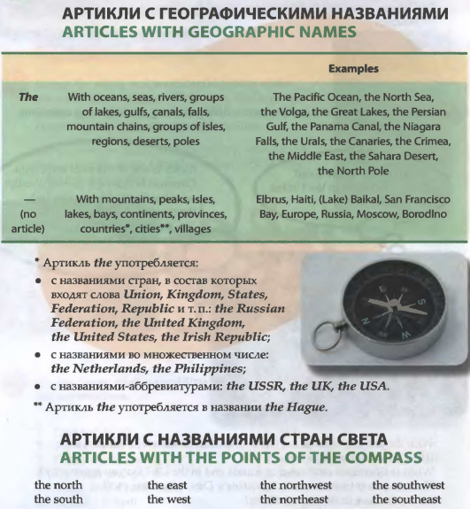

**4. Which of the geographic names are used with the article? Write them down**

1. Yenisei 2. Tokyo 3. South Pole 4. Laptev Sea 5. Egypt 6. Philippines 7. Indian Ocean 8. Sakhalin 9. People's Republic 10. Suez Canal 11. USSR 12. China 13. Middle East 14. Netherlands 15. Quebec 16. Kara-Kum 17. Ukraine 18. British Isles 19. Kilimanjaro 20. Far East 21. Hudson Bay

**5. Read the text.**

DISCOVER BRITAIN: ENGLAND

The United Kingdom is very small compared with many other countries in the world. However there are only nine other countries with more people, and London is the wor1d’s seventh biggest city. When you travel about the country you can see how the scenery changes right in front of your eyes. Highlands turn into lowlands, forests and hills turn into meadows and plains very quickly. Often what people first notice about Britain, especially if they arrive by plane, is the green of the fields, hedges and trees. Britain is an unusually beautiful country!

**The Southeast** is a highly populated region of England; there is a lot of industry near the Thames and there are a lot of roads and motorways. London, the capital of the UK, and such historical cities as Windsor, Dover and Brighton are situated here. When people travel to Britain by sea or air they usually arrive in the Southeast, for this is where the main passenger ports and airports are. Heathrow Airport, one of the world's busiest airports is about 33 km west of central London. However, there is still attractive countryside in the Southeast. The County of Kent situated here is known as the garden of England. The Southeast is famous for its resorts, Brighton is, probably, the best known of them.

**The Southwest** is the region where the main activity is farming. Although there are some very big farms, most of them are small family farms where dairy products are produced. The Southwest used to be known for its pirates. The romantic past makes it a popular place for artists, writers and holidaymakers. The two principal cities of the region are Bristol and Bath. If you want to see the famous Stonehenge, one of the remarkable historic places in the UK, you should also come here. The most westerly point of Great Britain “Land's End” is also in the Southwest.

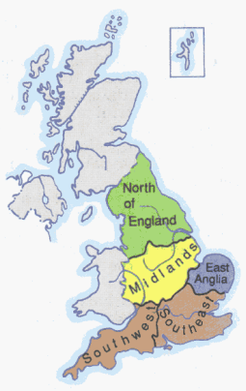

**East Anglia** is very flat and it is another farming region. It has beautiful cities, such as Cambridge, with fine historic buildings. The part of East Anglia called the Fens consists of miles of flat land with almost no trees or hedges. It used to be partly covered by the sea and now produces good harvests. Oliver Cromwell, an English general and politician (1599-1658) who was leader of the army against King Charles I in the Civil War and later became Lord Protector of England, was born in the Fens area. East Anglia is isolated from the rest of Britain because of its position away from the main national roads and because of its shape: it is more than half surrounded by the sea.

**The Midlands**, known as the heart of England, is the largest industrial part in the country. The most important industrial cities are Manchester, Sheffield, Liverpool, which is one of Britain’s big ports, and Birmingham. The two famous Midlands cities, Stratford-upon-Avon and Oxford are connected with English culture: Stratford is the birthplace of the great William Shakespeare and Oxford is famous for its university.

**The North of England** has some of the wildest and loneliest parts of the country, but also some of the busiest industrial cities. Here you can find deep valleys, rivers and waterfalls, hills and mountains. This part of the country is rich in coal which is important for the region’s industry. The main attractions of the North of England are certainly the Lake District, the cities of York and Newcastle-upon-Tyne. Many tourists come over especially to look at the ruins of Hadrian’s Wall, a stone wall built across the North of England by the order of the Roman ruler Hadrian to defend the Northern border of Roman Britain from the Scottish tribes.

**6. Fill in the table with some facts about the parts of England.**

|  |  |  |  |  |
| --- | --- | --- | --- | --- |
| **The Southeast** | **The Southwest** | **East Anglia** | **The Midlands** | **The North of England** |
|  |  |  |  |  |

**7. Look through the text again and answer these questions.**

1. How big is London compared with other cities?

2. Where do people usually arrive when they travel to Britain by sea or air? Why?

3. What are the principal cities in the Southeast?

4. What county is called the “garden of England”?

5. What is the Southeast famous for?

6. Why do people find the Southwest attractive?

7. Why is Land’s End called that way?

8. Why do you think tourists often come to Cambridge?

9. Where was Oliver Cromwell from‘? What can you say about the man?

10. What are the most important industrial cities in England?

11. What is Stratford-upon-Avon famous for?

12. What are the main attractions of the North of England?

13. What do you know about Hadrian’s Wall?

**8. Guess what the names of the places marked with the numbers. Write numbers and words.**

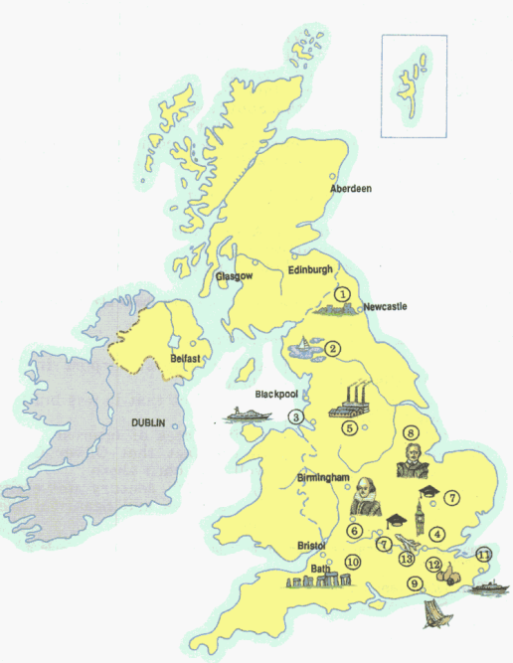

**Квест по теме «England»**

**1. Станция Англия.** Вам дано три задания. В первом задании нужно соединить карточки с описанием личности и именем. Во втором задании необходимо найти информацию в интернете и выбрать пропущенное слово/фразу. В третьем задании нужно соединить части англоязычных городов и назвать количество городов вне Англии. Из ответов собирается цифровой код.

|  |  |  |  |  |  |  |  |  |  |  |  |
| --- | --- | --- | --- | --- | --- | --- | --- | --- | --- | --- | --- |
| **Задание 1** | | | | | | | **Задание 2** | | | | **Задание 3** |
| **1** | **2** | **3** | **4** | **5** | **6** | **7** | **A** | **B** | **C** | **D** | **Сколько городов вне Англии здесь зашифровано?** |
|  |  |  |  |  |  |  |  |  |  |  |  |

**Завершающее задание квеста**: сопоставьте полученные цифры с буквами английского алфавита и получите первые два слова кода.

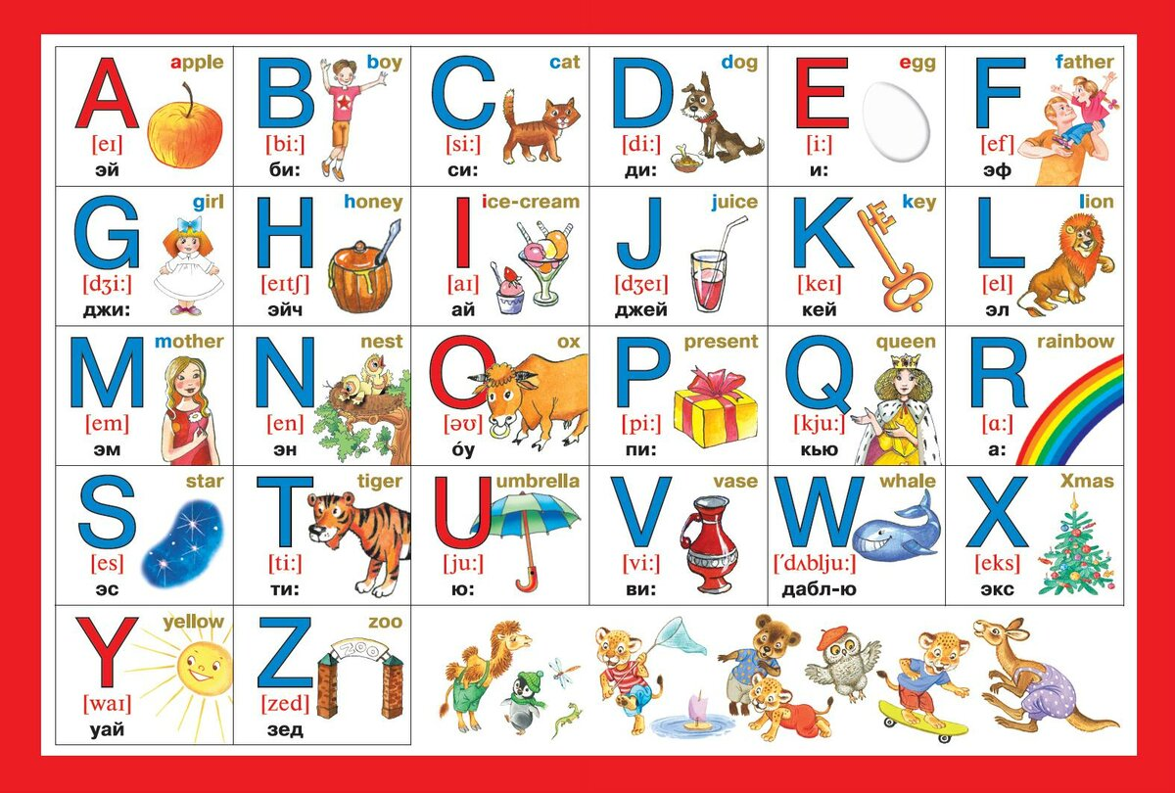

Ответ по станции England: __ __ __ __ __ __ __ __ __ __ __ __

England

**1. Match the famous English persons with their descriptions.**

|  |  |
| --- | --- |
| 1. This person has written Romeo and Juliet. 2. This person is the musician and member of The Beatles. 3. This person has created stories about Harry Potter. 4. This person has invented penicillin. 5. This person was a Prime Minister of Great Britain in 1940-1955 6. This person founded the hypothesis that man came from apes. 7. This man is a famous footballer. He gained his fame playing in Manchester United. | 2) Charles Darwin  5) David Beckham  26) Alexander Fleming  5) Shakespeare  12) John Lennon  1) Winston Churchill  9) Joanne Rowling |

**2. Find the missing information using the Internet.**

**A.** The Cooper's Hill _____ and Wake is an annual event held on the Spring Bank Holiday at Cooper's Hill near Gloucester in England. It is traditionally done by and for the people who live in the local village of Brockworth, but now people from all over the world take part. The Guardian called it a "world-famous event", and indeed, in 2013, a 27-year-old American man and a 39-year-old Japanese man each won one of the four races.

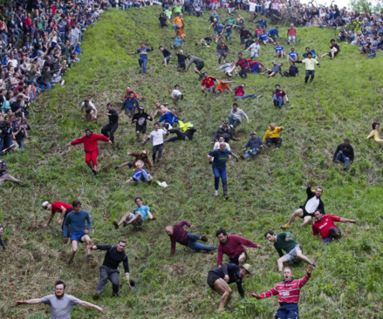

15) Meat-Balling 20) Cheese-Rolling 8) Watermelon-Rolling 19) Stones-Rolling

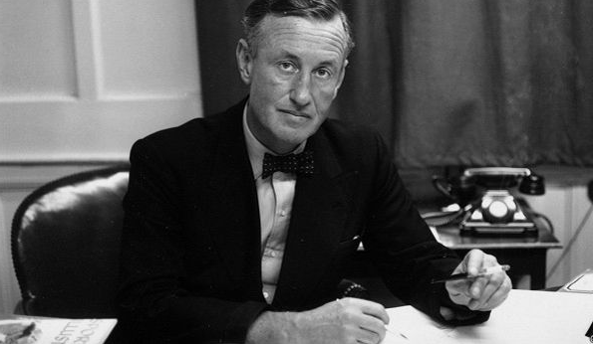

**B.** The James Bond series focuses on a fictional British Secret Service agent created in 1953 by writer _____, who featured him in twelve novels and two short-story collections.

15) Douglas Adams 20) George Orwell

19) Charles Dickens 8) Ian Fleming

**C.** It was made by British designer Thomas Heatherwick. It consists of eight triangular sections hinged at the walkway level and connected above by two-part links that can be collapsed towards the deck by hydraulic cylinders. When extended, it is 12 metres long. To allow the passage of boats, the hydraulic pistons are activated and the _____ curls up until its two ends join, to form an octagonal shape measuring one half of the waterway's width at that point.

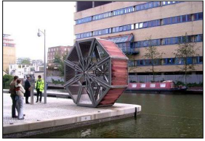

20) Rolling Bridge 8) Life Circle 15) Futurama 19) Love Circle

**D.** In November 1605 a group of men decided to make a plot to blow up the Houses of Parliament in London. The men were angry about the way the Catholic people were being treated in England. At this time the King of England was James the first. The plot is known as the ‘Gunpowder Plot’ and the leader of the plot was called _____.



The men put 36 barrels of gunpowder in the Houses of Parliament and they waited for the King to open Parliament. _____ was the man who was going to light the gunpowder and cause the explosion. However, police found the gunpowder before it could be exploded and they caught all the men involved in the plot.

15) Maud Gonne 20) Gerrard Winstanley 8) Guy Fawkes 19) Eleanor Marx

**3. Match the two parts of the names of cities.**

|  |  |  |
| --- | --- | --- |
| **DON** | **CAM** | **POOL** |
| **BRIDGE** | **OTTA** | **MAN** |
| **LIVER** | **FIELD** | **WELLIN** |
| **CAN** | **LON** | **CHESTER** |
| **KONG** |  | **BERRA** |
| **CHESTER** | **FORD** | **GTON** |
| **RO** | **BIRMIN** | **CAI** |
| **OX** | **WA** | **FORD** |
| **STRAT** | **HONG** | **GHAM** |

**How many cities are not situated in England? ___**

attractions:

🠢 main cities: Caerphilly, Newport, Swansea

🠢 country of castles: over 100 🠢 Conwy Castle, castles of Caernarfon, Cardiff, Harlech, Beaumaris

🠢 fictional castle **Camelot / Caerleon** (**King Arthur**)

🠢 national parks: Snowdonia NP 🠢 Snowdon (1,085m) ⭢ mountain railway to the top

Brecon Beacons NP, Pembroke NP

🠢 Tenby: popular holiday centre

🠢 festivals: love music 🠢 July: festival of music + poetry = International Eisteddfod in Llangollen

⭢ road signs in Welsh + English

flag: red dragon on a green + white field

patron: St. David (crusader)

area: 20,779 sq km

capital: Cardiff (old Roman fort) – cartoon capital

people: 2.9 million Welsh

anthem: Hen Wlad Fy Nhadau (Land of my Fathers)

language: Welsh (Cymru), English

symbol: dragon (official animal), daffodil, leek; Welsh feathers (Prince of Wales feathers)

countryside: mountainous country, coal mines, valleys

river Towy, small farms + sheep

national day: 1 March

religion: Anglicanism, Methodist

principality: Prince of Wales (Charles)

Wales is famous for ...

🠢 its national parks + long bridges

🠢 its actors: Richard Burton, Catherine Zeta Jones, Sir Anthony Hopkins

🠢 its explorers: Sir George Everest (highest mountain in the world)

🠢 its writers: Roald Dahl

🠢 its musicians: Tom Jones, Sherley Bassey

⭢ its caves (King Arthur's Labyrinth in Corris)

⭢ its legends: dragons, Merlin, Arthur, leek

⭢ Celtic history, druids

⭢ longest name for a village

⭢ love spoons

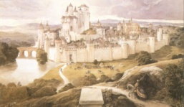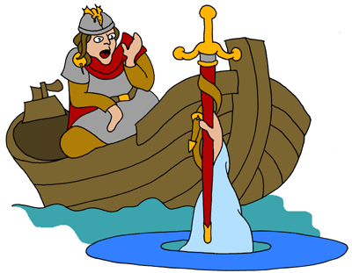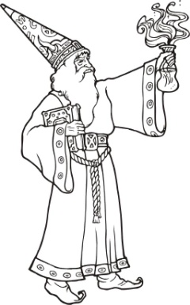

eating and drinking:

🠢 laverbread: seaweed, seafood

🠢 bara brith (fruit cake)

🠢 cawl cennin (leek stew)

🠢 Welsh cake, lamb, potato soup

sports and events:

🠢 rugby (Arms Park): sing loudly in stadiums

🠢 eight 18-hole golf courses

🠢 90 tennis courts

🠢 15 bowling centres + more leisure centres

🠢 Roath Park Lake

🠢 Wales National Ice Rink 🠢 Red Devils

history:

⭢ 4,000 BC: Celtic villages ("Wealas")

⭢ 48 AD: Roman invasion

⭢ 6th century: Angles + Saxons

⭢ 1066: Norman invasion

⭢ 1282: conquered by Edward I (England)

⭢ 1536: Henry VIII: Acts of Union

⭢ 1999: Welsh Assembly

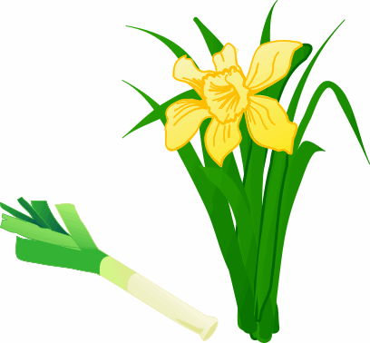

WALES FOREVER

= Cymru am byth =

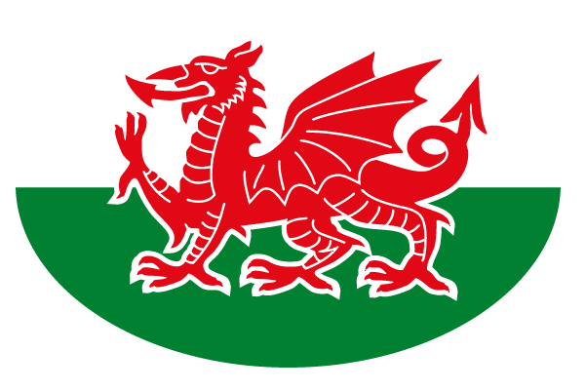

Wales

**1. Choose the flag of Wales. Why isn’t it a part of The Union Jack?**

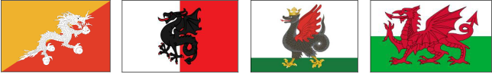

2) 17) 1) 19)

**2. Match the questions with the answers.**

1. What is the geographical position of Wales?
2. What is the capital of Wales?
3. What are the national symbols?
4. Is this an industrial country or an agricultural?
5. What is the main economic activity in the country?
6. On what languages do people speak in Wales?
7. How do we call people in Wales?
8. What is the highest mountain in Wales?
9. What is the national game of Wales?
10. What does the word “Cymru” mean?
11. What are the big cities in Wales?

19) The British, the Welsh

8) Rugby

17) Swansea, Newport

9) English, Welsh

3) Cardiff

20) Mount Snowdon

5) It’s a name the Welsh call their country

15) A leek, a daffodil

5) In the South-West of Great Britain

14) An agricultural country

4) Farming

|  |  |  |  |  |  |  |  |  |  |  |  |
| --- | --- | --- | --- | --- | --- | --- | --- | --- | --- | --- | --- |
| **Задание 1** | **Задание 2** | | | | | | | | | | |
| **1** | **1** | **2** | **3** | **4** | **5** | **6** | **7** | **8** | **9** | **10** | **11** |
|  |  |  |  |  |  |  |  |  |  |  |  |

**Завершающее задание квеста**: сопоставьте полученные цифры с буквами английского алфавита и получите первые два слова кода.



Ответ по станции Wales: __ __ __ __ __ __

__ __ __ __ __ __

**1. Read the text.**

SCOTLAND

Although Scotland forms a part of the United Kingdom, it has a distinct character of its own. In area it is more than half as big as England. Its population is, however, only one-eighth as great — about 5 200 000.

Scotland is a land of romance and it has had a most eventful history. The Picts and Celts lived there before the coming of the Romans to Britain. Those Northern tribes worried the Romans so much that the Great Wall was built to protect the Roman camps in the Northern part of England.

It was in the 11th century that the Normans began to settle in Scotland. Almost all of Scotland's history is associated with and reflected in many castles and forts that are to be seen all over the country. They are very picturesque, having retained their medieval features: stern, proud, impressive, perched high on a rock or at a hillside. Mary, Queen of Scots, the beautiful Mary Stuart was married in one of them, her son James (who was to become James I of England) was born in another.

And now some words about the Highlands. For centuries the Highlands were a strange land, where the king's law common to all the rest of the country, wasn't even known, where C Long after the rest of Britain adopted modern ways they kept to the old life.

In 1603 King James VI of Scotland became King James I of England too, and from then onwards the countries were under the same monarch, though the Act of Union was not passed until 1707. This Act incorporated Scotland with England in the United Kingdom, but the Scots kept their own legal system, religion and administration, centred in Edinburgh.

Edinburgh – the capital of Scotland has always been admired as one of the most beautiful cities. Glasgow – its second city – always had a bad reputation. It was too often seen as a dirty, run-down urban area. But no longer. The buildings have been cleaned up, the streets are tidy and the people now take an obvious pride in their city. Glasgow was chosen to be the cultural capital of Europe 1890.

Not far from Glasgow there is one of the most famous of Scotland's many lakes (called «lochs»), Loch Lomond. Scottish numerous valleys are known as «glens». Scotland is a country with an intense and living national tradition of a kind only too rare in the modern world. It has its distinctive national dress, the kilt, worn only by men. It also has its own typical musical instruments (the pipes, sometimes called «the bagpipes»), its own national form of dancing, its own songs, language, traditions and education. Scotland has even its own national drink, a fact so widely known that one need only ask for «Scotch».

*Notes*

The Picts and Celts – пикты и кельты (племена)

tribe — племя

camp — лагерь

to pass the Act — принять Акт/Закон (в парламенте)

**2. Тranslate using the text**

1.полный событий

2.доставлять неприятности

3.заселять

4.замок

5.живописный

6.средневековые качества

7.законы короля

8.объединять

9.сохранить свою собственную религию

10.иметь плохую репутацию

11.грязная, жалкая местность

12.явная гордость

13.не далеко от

14.многочисленные долины

15.сохранять

16.располагались высоко

17.иметь плохую репутацию

18.национальная одежда для мужчин

19.волынка

20.широко известен

**3. Complete the sentences.**

1. Scotland forms...

2. The Northern tribes...

3. Mary Stuart...

4. The kilt...

**4. Answer the questions.**

1. What is the population of Scotland?

2. Why was the Great Wall built?

3. Why are there so many castles in the country?

4. What have you learnt about the Highlands?

5. When was the Act of Union passed?

6. What's the country's second city?

7. What do they call Scottish valleys and lakes?

8. Are national traditions still alive in Scotland?

**5. Put down words, and translate the sentences into Russian.**

1. Scotland has … history.

2. The Great Wall was built … in the Northern part of England.

3. Scotland's history is associated with … that are to be seen all over the country.

4. The Highlands were a strange land, where the king's law …

5. The Scots kept their… , centered in Edinburgh.

6. Glasgow was seen … area.

7. People now … in Glasgow.

8. The kilt is … , worn only by men.

Scotland